**Assignment – 3**

**Financial Analytics**

**Title : Analyzing competitive advantage in real companies**

**CONTENT**

* **Introduction**
* **Background**
* **Competitive advantage**
* **Financial performance evaluation**
* **Comparative analysis**
* **Assessment of sustainability**
* **Conclusion**

In this task I am analysing the competitive advantage of two real companies operating in different industries. One company from technology sector i.e. **DELL TECHNOLOGIES INC** and another from the consumer goods sector i.e. **UNILEVER**.

* **Introduction**
* **Company from technology sector :** **Dell Technologies Inc**

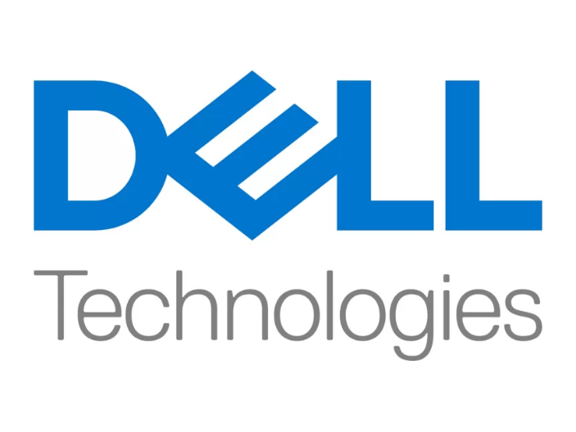

**Dell Technologies Inc.** is an American multinational technology company headquartered in Round Rock, Texas. It was formed as a result of the September 2016 merger of Dell and EMC Corporation (which later became Dell EMC).

Dell's products include personal computers, servers, monitors, computer software, computer security and network security, as well as information security services. Dell ranked 35th on the 2018 Fortune 500 rankings of the largest United States corporations by total revenue.

Approximately 50% of the company's revenue is derived in the United States.

Dell operates under two divisions:

* Dell Client Solutions Group (48% of fiscal 2019 revenues) – produces desktop PCs, notebooks, tablets, and peripherals, such as monitors, printers, and projectors under the Dell brand name
* Dell EMC Infrastructure Solutions Group (41% of fiscal 2019 revenues) – servers, storage, and networking

Dell divested its ownership in Boomi, VMware (80%)and Pivotal Software, but owns other businesses such as Secureworks, Virtustream.

* **Company from consumer goods sector** : **UNILEVER**

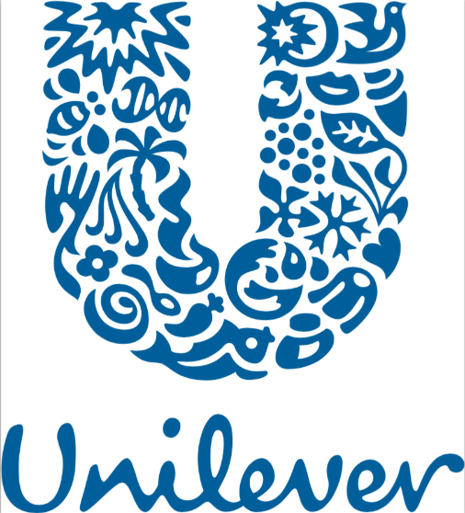

**Unilever PLC** is a British multinational fast-moving consumer goods company founded on 2 September 1929 following the merger of British soap maker Lever Brothers and Dutch margarine producer Margarine Unie. It is headquartered in London.

Unilever products include baby food, beauty products, bottled water, breakfast cereals, cleaning agents, condiments, energy drinks, healthcare and hygiene products, ice cream, instant coffee, pet food, pharmaceuticals, soft drinks, tea, and toothpaste. It is the largest producer of soap in the world, and its products are available in over 190 countries.

Unilever's largest brands include Axe (Lynx), Ben & Jerry's, Dove, Hellmann's, Knorr, Lifebuoy, Lux, Magnum, Omo (Persil), Rexona, Sunlight, Sunsilk, and Wall's (Heartbrand). The company is organised into five business groups: Beauty & Wellbeing, Personal Care, Home Care, Nutrition, and Ice Cream. It has research and development facilities in China, India, the Netherlands, the United Kingdom, and the United States.

* **Background**

1. **Company name : DELL TECHNOLOGIES INC**

Michael Dell founded Dell Computer Corporation, doing business as *PC's Limited* in 1984 while a student at the University of Texas at Austin, operating from Michael Dell's off-campus dormitory room at Dobie Center. The start-up aimed to sell IBM PC compatible computers built from stock components. Michael Dell started trading in the belief that, by selling personal computer systems directly to customers, PC's Limited could better understand customers' needs and provide the most effective computing solutions to meet those needs. Dell dropped out of college upon completion of his freshman year at the University of Texas in order to focus full-time on his fledgling business, after getting about $1,000 in expansion-capital from his family. As of April 2021, Dell's net worth was estimated to be over $50 billion (equivalent to $53,530,000,000 in 2022)

1. **Company name : UNILEVER**

Unilever Plc (Unilever) is a manufacturer and supplier of fast-moving consumer goods. The company's product portfolio comprises food products, beauty and personal care products, beverages, home care products, vitamins, minerals, and supplements.

In September 1929, Unilever was formed by a merger of the operations of Dutch Margarine Unie and British soapmaker Lever Brothers, with the name of the resulting company a portmanteau of the name of both companies.[[7]](https://en.wikipedia.org/wiki/Unilever#cite_note-Unilever_global_company_website-8) In the 1930s, the business grew, and new ventures were launched in Africa and Latin America.

* **Competitive advantages**

comparing competitive advantages of both the companies.

|  |  |  |
| --- | --- | --- |
| **Company name** | **DELL Technologies Inc** | **UNILEVER** |
| **Brand reputation** | Dell has a strong brand reputation, which it has built over the years through advertising and marketing campaigns. The company's advertising campaigns are designed to highlight the benefits of its products and services and communicate its brand message to potential customers. | The extensive analysis of FMCG brands measures which brands are being bought by the most consumers, most often, around the world. It examines around 1bn households and 300bn shopper decisions across 39 countries.  Unilever’s brands include Knorr, Dove, Lux, and Sunlight, all of which feature in the top 20, with Lifebuoy, the world's leading health soap, at number 3. Unilever’s Brooke Bond Tea is a new addition to the top 50. Sunlight features as the top Homecare brand, with Dove adding the most consumers to its portfolio reaching 14 million new households.  Keith Weed, Unilever Chief Marketing and Communications Officer, said: “Increasingly we see that people want to buy from companies and brands that not only have great products at the right price, but also fit with their values.” |
| **Product differentiation** | Dell’s marketing and product strategy has differed from that of its major competitors, such as HP and Lenovo, in several ways over the years. Here are some of the key differences:  Direct Sales Model: One of the key differences between Dell and its competitors is its direct sales model. Unlike HP and Lenovo, which primarily sell their products through third-party retailers and distributors, Dell sells its products directly to customers through its website, call centers, and field sales teams. This direct sales model gives Dell more control over the customer experience and offers more customization options | Unilever uses broad differentiation as its generic strategy for competitive advantage. The focus of this generic competitive strategy is on features or characteristics that make the company's consumer goods stand out against competitors. Innovation: Unilever invests heavily in research and development, leading to innovative product offerings that help to drive growth and differentiate the company from its competitors |
| **Technological innovation** | Dell leads enabling standards and technologies through industry groups and strategic partners. We partner, rather than compete, with top industry technology suppliers and original development manufacturers. These partnerships give us a uniquely broad perspective on the computing landscape.  Since the first Dell PC was introduced in 1986, Dell has continued to shape the industry by breaking new ground and pioneering critical developments in home, small business and enterprise computing. We gather requirements directly through tens of thousands of daily customer interactions, organized events, social media venues and customer panels. Maintaining strong internal development capabilities, we spur innovation that delivers value to customers | Unilever has been involved in various technological innovations across its operations, particularly in the areas of sustainability, product development, and supply chain management. While I can't provide real-time updates, here are some examples of technological innovations that Unilever has been known for. |
| **Market leadership** | Dell has long been a dominant player in the PC market. The company offers a wide range of desktops, laptops, and workstations catering to both consumer and enterprise markets. Dell's products are known for their quality, performance, and customization options, allowing customers to tailor their devices to their specific needs. | Unilever is a market leader in the FMCG sector, offering a diverse range of products across various categories such as home care, personal care, food and beverages. Some of its well-known brands include Dove, Lipton, Knorr, Axe, and Ben & Jerry's. Its extensive product portfolio and global reach contribute to its market leadership in this sector |
| **Distribution network** | Dell is well-known for its direct sales model, which bypasses traditional retail channels and sells directly to customers. This approach allows Dell to maintain tight control over its distribution process, optimize inventory management, and build direct relationships with its customers. | Unilever operates in over 190 countries worldwide, and its distribution network spans across regions and continents. This extensive global presence allows Unilever to reach a diverse range of consumers with its products. |

* **Analysing financial performance**
* **Analysing financial performance of**

**Technology company : DELL Technologies Inc**

1. **Revenue growth:** Dell today announced financial results for its fiscal 2024 first quarter ended December 30, 2023. The Company posted quarterly revenue of $119.6 billion, up 2 percent year over year, and quarterly earnings per diluted share of $2.18, up 16 percent year over year.

For the first quarter of their 2024 fiscal year, DELL reported a revenue of 119.6 billion U.S. dollars.

1. **Profit margins:**

Profit margin can be defined as the percentage of revenue that a company retains as income after the deduction of expenses. Net profit margin as of December 31, 2023 is 26.16%.

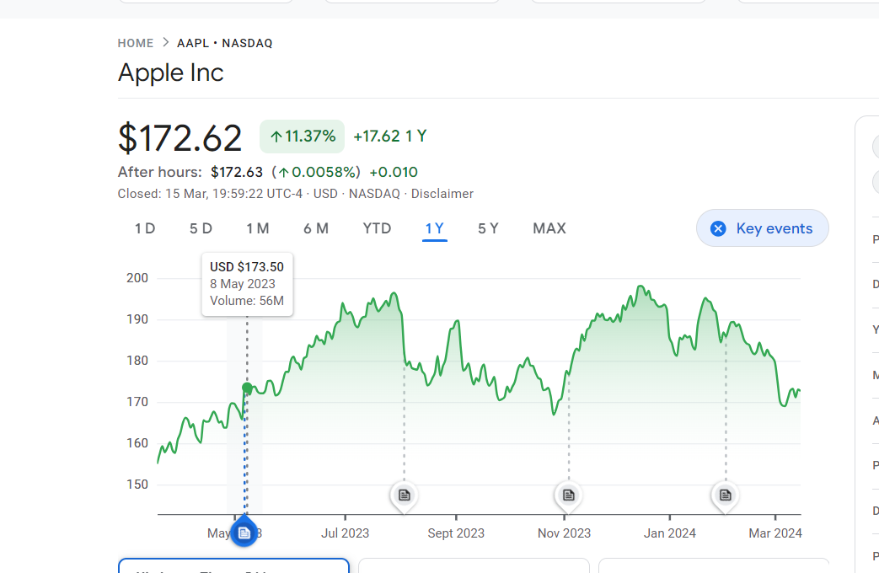

1. **Return on investment:**

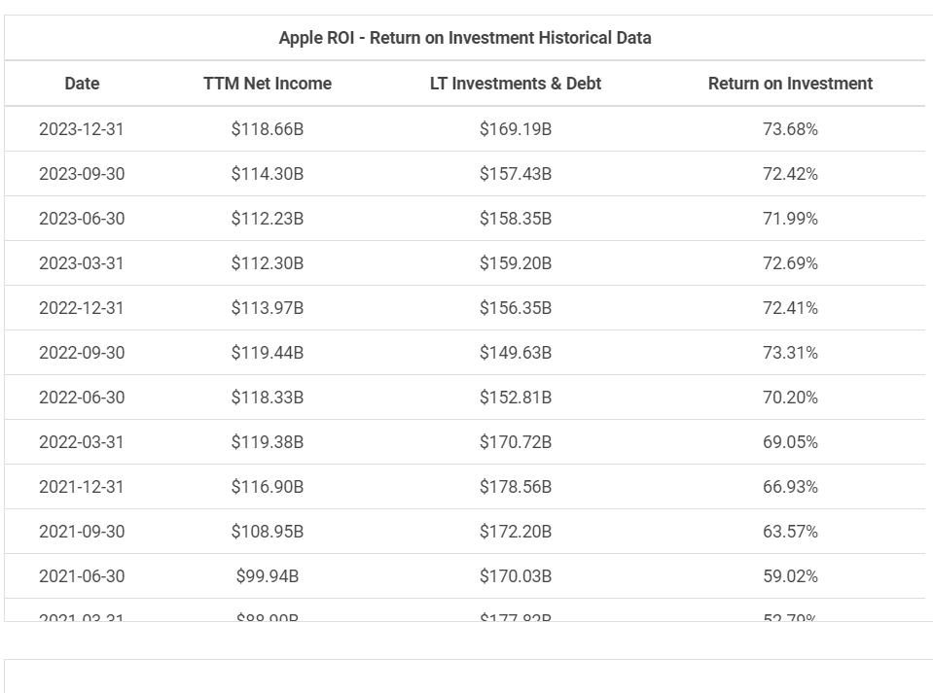

1. **Market share :**

Dell is one of the leading vendors of personal computers globally. The company has consistently ranked among the top PC manufacturers in terms of market share. Its product lineup includes desktops, laptops, workstations, and gaming PCs, catering to both consumer and business markets.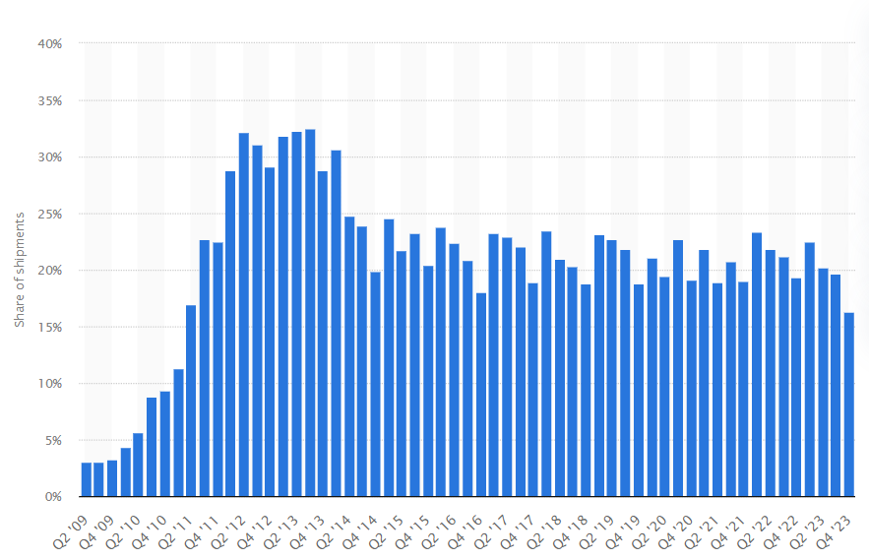

* **Analysing financial performance of**

**Consumer goods service company : UNILEVER**

1. **Revenue growth:**

Organic growth reached 7.2%, with pricing of 7.5% and real internal growth (RIG) of -0.3%. Growth was broad-based across geographies and categories. Total reported sales were CHF 93.0 billion, a decrease of 1.5% (FY-2022: CHF 94.4 billion).

The underlying trading operating profit (UTOP) margin was 17.3%, increasing by 20 basis points on a reported basis and by 40 basis points in constant currency. The trading operating profit (TOP) margin was 15.6%, increasing by 160 basis points.

1. **Profit margin:**

FMCG major Nestle India on Wednesday reported a net profit of Rs 656 crore for the quarter ended December 2023, which is up 4% year-on-year (YoY) from Rs 628 crore posted in the same quarter last year. Revenue from operations rose 8% YoY to Rs 4,584 crore in the reporting fourth quarter.

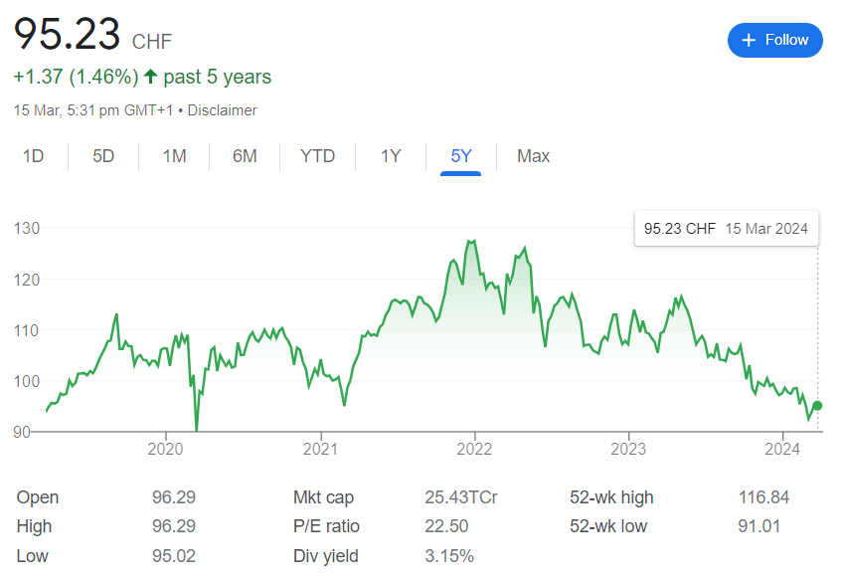

1. **Return on investment:**

UNILEVER SA DRC's return on invested capital hit its 5-year low in December 2021 of 12.8%. UNILEVER SA DRC's return on invested capital decreased in 2020 (13.2%, -3.8%) and 2021 (12.8%, -3.2%) and increased in 2019 (13.8%, +4.7%), 2022 (13.0%, +1.2%), and 2023 (13.6%, +4.8%).

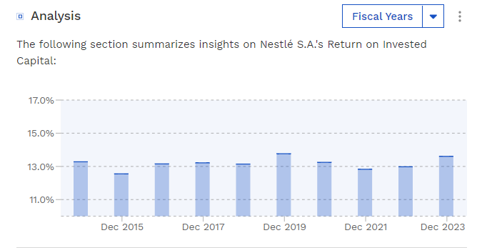

1. **Market share:**

As of March 2024 UNILEVER has a market cap of $282.42 Billion. This makes UNILEVER the world's 37th most valuable company by market cap according to our data.

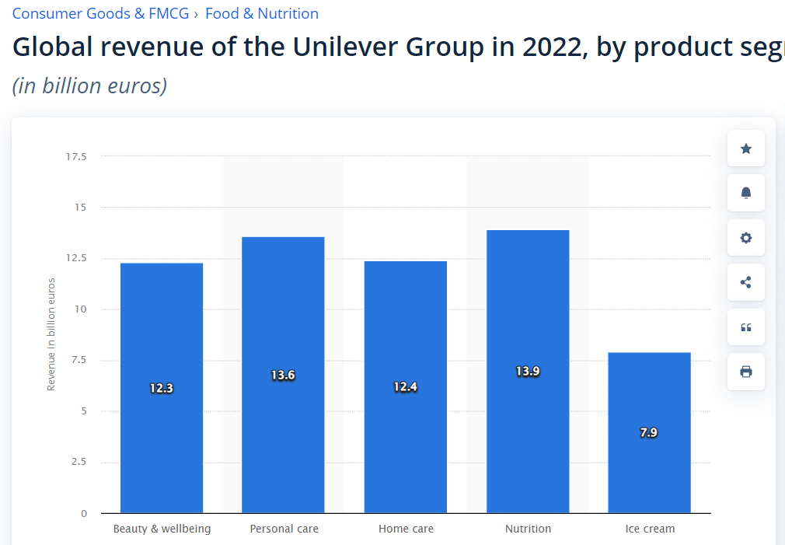

* **Compare competitive positions**

|  |  |  |
| --- | --- | --- |
| **Company name** | **DELL Technologies Inc** | **UNILEVER** |
| **Market share** | Dell is one of the leading vendors of personal computers globally. The company has consistently ranked among the top PC manufacturers in terms of market share. Its product lineup includes desktops, laptops, workstations, and gaming PCs, catering to both consumer and business markets. | As of March 2024 UNILEVER has a market cap of $282.42 Billion. This makes UNILEVER the world's 37th most valuable company by market cap according to our data |
| **Growth prospects** | The shift to remote and hybrid work models has accelerated demand for technology solutions that enable collaboration, productivity, and connectivity. Dell's portfolio of laptops, desktops, monitors, and peripherals positions it well to cater to the evolving needs of businesses and individuals working remotely or in hybrid environments. | Unilever has been focusing on expanding its presence in emerging markets, where there is a growing middle class and increasing consumer spending. These markets offer significant growth opportunities for Unilever's products across categories such as personal care, home care, and food and beverages. |
| **Competitive threats** | Dell competes with other PC manufacturers such as HP Inc. (Hewlett-Packard), Lenovo, and Apple. These competitors offer a range of desktops, laptops, and other computing devices, and they often innovate with new features and designs to attract customers. | Unilever faces competition from a wide range of global and local competitors across its product categories. Major rivals include Procter & Gamble, Nestlé, The Coca-Cola Company, PepsiCo, and other multinational consumer goods companies, as well as local brands that cater to specific regional markets. |
| **Barriers to entry** | Dell is a well-established brand with a strong reputation in the technology industry. Its brand recognition and reputation for quality and reliability give it a competitive advantage over new entrants who may struggle to gain trust and credibility among consumers and businesses. | Unilever owns numerous well-known brands across various product categories, including personal care, home care, and food and beverages. Brands such as Dove, Lipton, Knorr, and Axe enjoy strong brand recognition and loyalty among consumers worldwide. This brand equity acts as a barrier to entry for new competitors trying to establish themselves in the market. |

* **Assessment of sustainability**

Sustainability assessment requires an evaluation of present and future conditions to show that present decisions and actions are not compromising future human and ecological health and well-being.

1. Technology company: **DELL Technologies Inc**

**Environmental Impact Reduction**: Dell has made significant strides in reducing its environmental footprint by implementing initiatives to minimize energy consumption, reduce greenhouse gas emissions, and decrease waste generation. The company has set ambitious targets to achieve by 2030, including using 100% renewable energy in its global electricity use and ensuring that 100% of its product packaging is sourced from sustainable materials or recycled content.

**Circular Economy Initiatives**: Dell has embraced the principles of the circular economy by designing products for longevity, reparability, and recyclability. The company operates a global recycling program that allows customers to return end-of-life products for responsible disposal or recycling. Dell also incorporates recycled materials into its product manufacturing processes, contributing to a more sustainable supply chain.

**Social Responsibility and Diversity**: Dell is committed to promoting social responsibility and diversity within its workforce and supply chain. The company has implemented various initiatives to support diversity, equity, and inclusion, including setting targets to increase representation of underrepresented groups in its workforce and leadership positions. Dell also prioritizes ethical sourcing practices and supplier diversity to ensure fair labor practices and human rights across its supply chain.

1. Consumer goods sector: **UNILEVER**

Unilever has made significant commitments to reduce its environmental footprint, including goals to achieve net-zero emissions from its products by 2039 and to ensure all its plastic packaging is reusable, recyclable, or compostable by 2025. The company focuses on reducing greenhouse gas emissions, water usage, and waste generation across its operations. Unilever also invests in sustainable sourcing of raw materials, such as palm oil and tea, to mitigate deforestation and biodiversity loss.

**Circular Economy Initiatives**: Unilever embraces the principles of the circular economy by designing products for recyclability and incorporating recycled materials into its packaging. The company has launched initiatives like the "Loop" platform, which offers refillable and reusable packaging options for its products, reducing single-use plastics. Unilever also operates recycling and waste management programs to minimize its environmental impact and promote a circular economy.

**Social Responsibility and Inclusion**: Unilever is committed to promoting social responsibility and inclusion within its workforce, supply chain, and communities. The company champions diversity, equity, and inclusion initiatives and sets targets to increase representation of underrepresented groups in its workforce and leadership positions. Unilever also prioritizes fair labor practices, human rights, and ethical sourcing throughout its supply chain, partnering with stakeholders to address social issues and promote responsible business practices.

* **Conclusion**

1. **DELL Technologies Inc**

Dell is a leading technology company with a strong market presence in various segments of the industry, including personal computers, servers, storage solutions, and IT services. The company has built its success on a foundation of innovation, quality, and customer-centricity, positioning itself as a trusted partner for businesses and consumers worldwide.

Dell's strategic focus on digital transformation, sustainability, and customer experience underscores its commitment to driving long-term growth and value creation. By leveraging its technological expertise, global reach, and strong brand reputation, Dell continues to adapt to evolving market trends and customer needs, while also addressing key challenges such as competition, pricing pressures, and technological disruption.

Overall, Dell's resilience, adaptability, and commitment to sustainability position it well for continued success in the dynamic and competitive technology landscape. As it navigates the opportunities and challenges of the digital age, Dell remains dedicated to delivering innovative solutions that empower individuals and organizations to thrive in an increasingly interconnected world.

1. **UNILEVER**

Unilever stands as a global powerhouse in the consumer goods industry, renowned for its extensive portfolio of brands spanning various categories such as personal care, home care, food, and beverages. With a commitment to sustainability, innovation, and social responsibility, Unilever has solidified its position as a leader in the market.

Unilever's strategic focus on sustainability is evident through its ambitious goals to reduce environmental impact, promote social inclusion, and foster responsible business practices. The company's dedication to the circular economy, ethical sourcing, and community engagement underscores its commitment to creating a positive impact beyond its bottom line.

Through its diverse brand portfolio, Unilever has established strong connections with consumers worldwide, leveraging its brand equity and reputation for quality and reliability. This, coupled with its robust distribution network and extensive global presence, enables Unilever to effectively reach and serve consumers across diverse markets and regions.

Despite facing challenges such as market competition, changing consumer preferences, and regulatory pressures, Unilever's resilience, adaptability, and commitment to its purpose-driven business model position it for continued success and growth in the years to come. As it continues to innovate, collaborate, and drive positive change, Unilever remains dedicated to building a brighter future for people and the planet.

1. Top of Form

***

**Name : M. Sunny Apuroop**

**College : DR. Lankapalli Bullayya College**